- We expect the Bank of England's Monetary Policy Committee to keep Bank Rate at 4% and to slow the pace of quantitative tightening at its next meeting on September 18.
- The chances of a September cut have always been low, but the MPC's hawkish messaging in August and the lack of dovish surprises in recent data have reinforced this view.
- We expect the MPC to reduce the stock of gilts held in the BoE's Asset Purchase Facility by £75bn over the next year, broadly in line with market expectations. This would be below last year's £100bn annual reduction. We think the BoE will look to focus active gilt sales on short- and medium-dated gilts rather than longs.
- Further rate cuts after September are still likely, but given the MPC's concerns around the risk of above-target inflation persisting, we expect the committee to adopt a more cautious approach. We think the MPC is likely to skip a cut in November then deliver two more 25bp cuts in 2026.
At the August meeting of the Bank of England's Monetary Policy Committee, the decision to cut Bank Rate by 25bps to 4% was unexpectedly tight, and the accompanying messaging was hawkish. In the meeting minutes, the MPC put renewed focus on the risk of above-target inflation persisting, shifting concerns about the strength of growth and the labour market to the back burner.
The pivot reflected two key worries. First, evidence of slowing pay growth is yet to be reflected in lower inflation, particularly in the services sector. And second, high headline inflation this autumn might lift inflation expectations among households and firms, particularly given that recent upward pressures have come from the highly salient food and fuel categories.
Since the start of the rate easing cycle, the MPC has cut at alternate meetings, so we've always viewed September as a 'hold' meeting. This has been reinforced by recent data, which has failed to deliver major dovish surprises (Chart 1). We expect the MPC to vote 8-1 to hold Bank Rate at 4%, with Alan Taylor voting for a 25bp cut. Financial markets agree, pricing just a 2% chance of a 25bp cut this month.
Chart 1: Recent inflation and pay data have failed to yield major dovish surprises
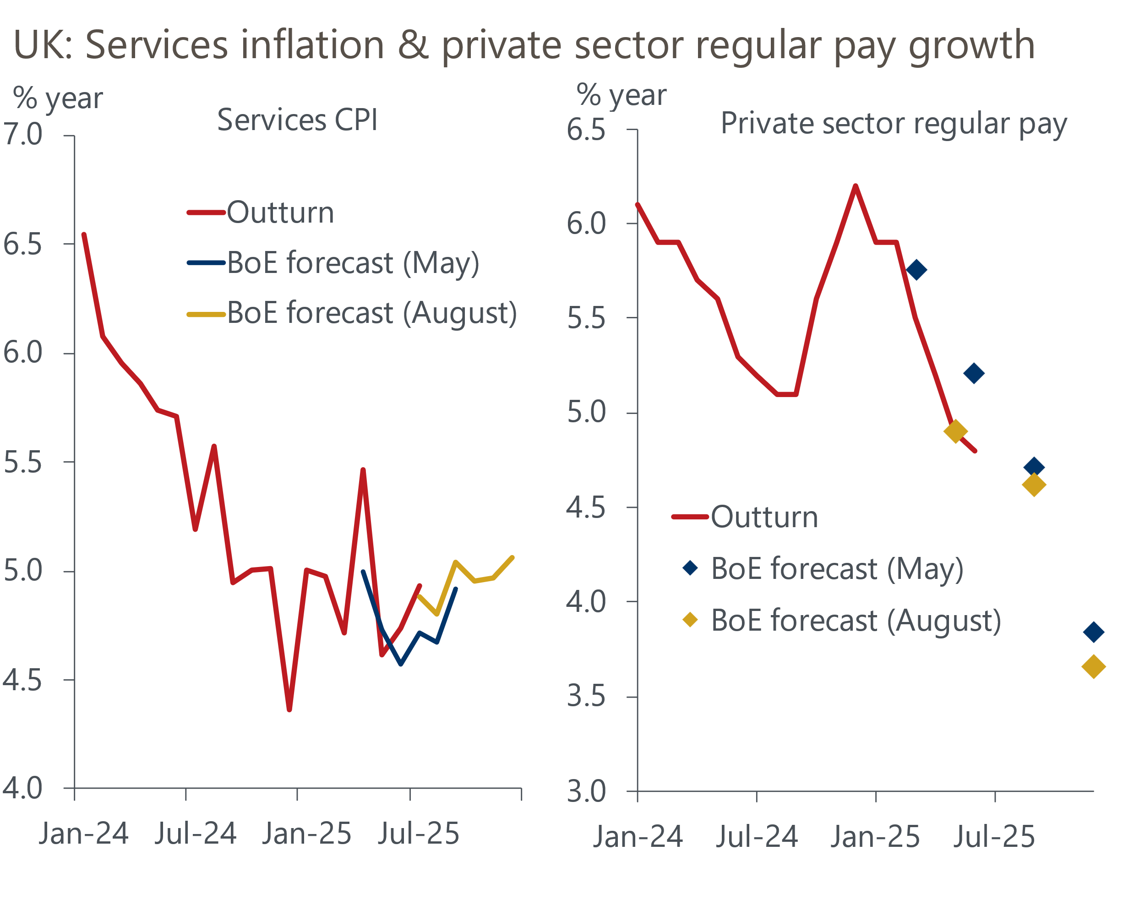
Sources: Haver Analytics, Bank of England Monetary Policy Report

The vote on the pace and shape of QT is likely to be the more interesting one
The MPC will also vote on the pace of quantitative tightening for the next 12 months at the September meeting. In the BoE's annual review of its QT programme in the August Monetary Policy Report, it argued that so far QT has had no marked impact on market liquidity, and only a modest 15bps-25bps upward impact on gilt yields. So QT is likely to continue, although there is a debate about the pace at which the BoE should run down the stock of gilts held in its Asset Purchase Facility.
In each of the past two years, the MPC has voted to reduce gilt holdings by £100bn. However, just £49bn of redemptions are due over the next year, so maintaining the same pace of QT would require the value of active gilt sales to rise sharply to £51bn, from just £13bn last year. The BoE's own Market Participants Survey reports a firm consensus among market participants that the MPC will slow the pace of QT to £72bn over the next year, implying a much more modest increase in active gilt sales of £23bn (Chart 2).
Chart 2: Consensus expectations suggest a significant slowdown in the pace of QT in 2025-2026
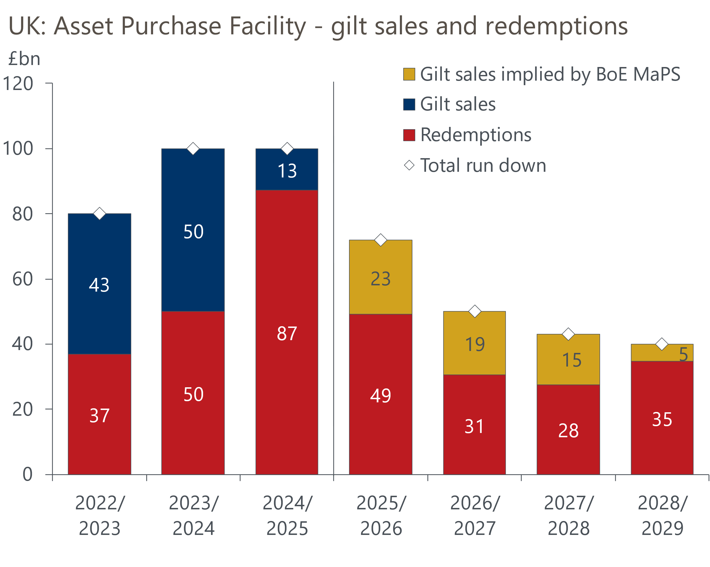
Sources: Oxford Economics calculations using data from Haver Analytics & Bank of England
We think the MPC will be aware that a decision that surprises markets significantly to the upside, such as maintaining the current £100bn pace, risks a sharp increase in gilt yields, particularly given recent volatility. Therefore, we believe the most likely outcome at the September meeting is that the MPC will lower next year's target to around £75bn, which implies active sales of roughly £26bn. But there's a chance the MPC may opt to go even further and undershoot the consensus to avoid the risk of disrupting markets.
The BoE has acknowledged that higher issuance of government bonds globally alongside structural changes within the domestic bond market that have reduced demand for long-dated gilts could pose a risk that QT has a greater impact on market functioning in the future. Therefore, we expect the BoE to focus active gilt sales on short- and medium-dated gilts rather than longs, where signs of market stress have been more acute – gilt yields have risen across most of the curve since the MPC's September 2024 QT decision, with the increase in longer yields being particularly large (Chart 3).
Given the APF holds £290bn of shorts and mediums (valued at purchase price), there is ample scope for active sales to be skewed towards these bonds. Such a move would also be in keeping with the Debt Management Office's recent decision to amend its 2025-2026 financing remit by skewing sales towards shorter-term bonds.
Chart 3: Gilt yields have risen sharply over the past year, particularly at the longer end of the curve
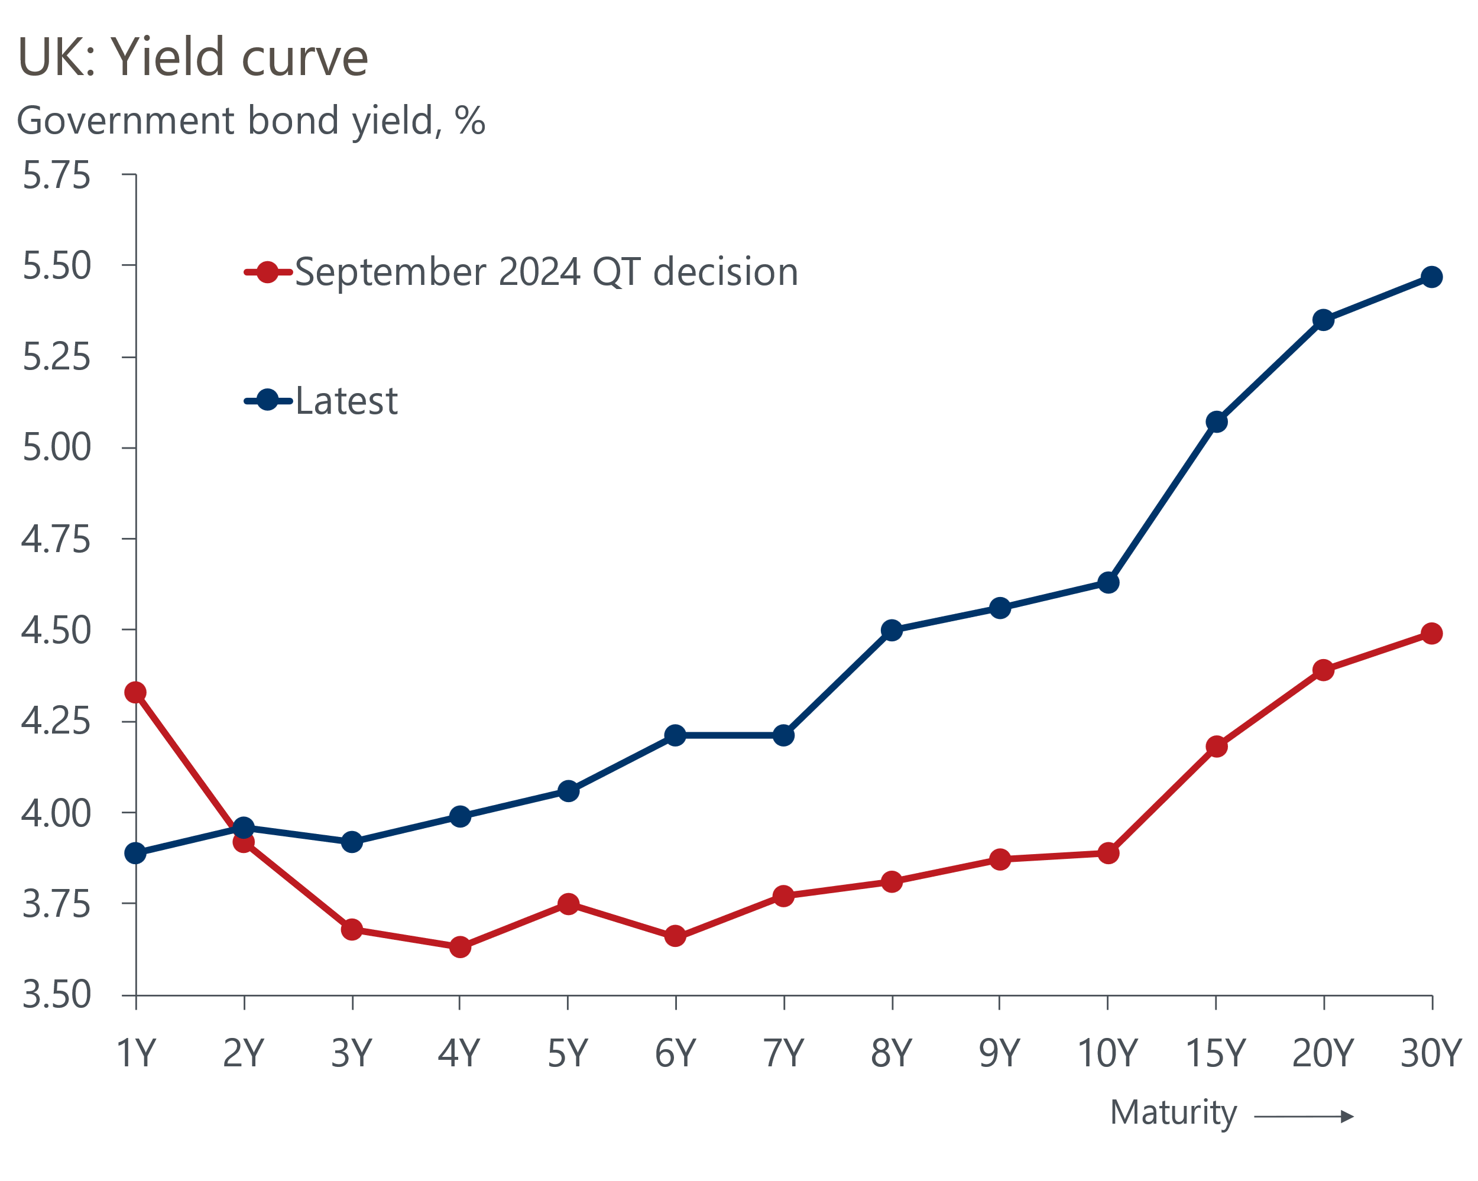
Source: Haver Analytics
We will also be watching closely to see whether the MPC provides a broad outline of its future steady-state balance sheet. The committee could confirm that it plans to run its QT stock down to zero and move entirely to its repo-based system for reserves. Alternatively, in line with recent suggestions from the IMF, the BoE may signal that it plans to continue holding some short-dated gilts in a small APF in the steady-state to align with currency in circulation.

We expect the MPC to adopt a more cautious approach to cutting rates
Despite the MPC's hawkish messaging in August, the committee has been clear that it still expects to cut Bank Rate further. With the four more hawkish members on the committee emphasising elevated inflation expectations and high inflation rates in the salient food and fuel categories, we think it's unlikely that this data will surprise in a way that convinces these members to change tack and support a rate cut in November.
Views among the five other MPC's members diverge widely, but it's clear that Governor Andrew Bailey is now the committee's swing voter. Following comments made in a recent Treasury Select Committee hearing, where he was keen to emphasise that the upside risks to inflation had risen and there was now more uncertainty of the timing of future rate cuts, we don't think Bailey is leaning towards a rate cut in November. As things stand, market pricing implies just a 19% probability of a 25bps rate cut at that meeting. If that is maintained, we think it unlikely that Bailey will be prepared to vote against market pricing, particularly given that any tightening of fiscal policy would not have been announced by that stage.
Our new forecast assumes the MPC won't cut Bank Rate again this year, though we suspect the November and December decisions will be close calls. We expect the committee's cutting cycle to resume in 2026. By then, the MPC will likely have to factor in the prospect of tighter fiscal policy. We expect growth to underperform the BoE's forecasts, providing evidence of additional spare capacity. Meanwhile, we think the committee will have greater certainty that pay growth is cooling to a target-consistent pace next year and the temporary factors behind the divergence in pay growth and services inflation are slowly fading.
We expect the MPC to take a cautious approach to loosening policy, particularly as it moves closer to the range that it considers to be equivalent to a neutral policy rate. We anticipate just two 25bp rate cuts in 2026. This would lower Bank Rate to 3.5% by the end of the year, which is still a little below current market expectations (Chart 4).
Chart 4: We expect the MPC to cut Bank Rate to 3.5% by end-2026, which is below market expectations
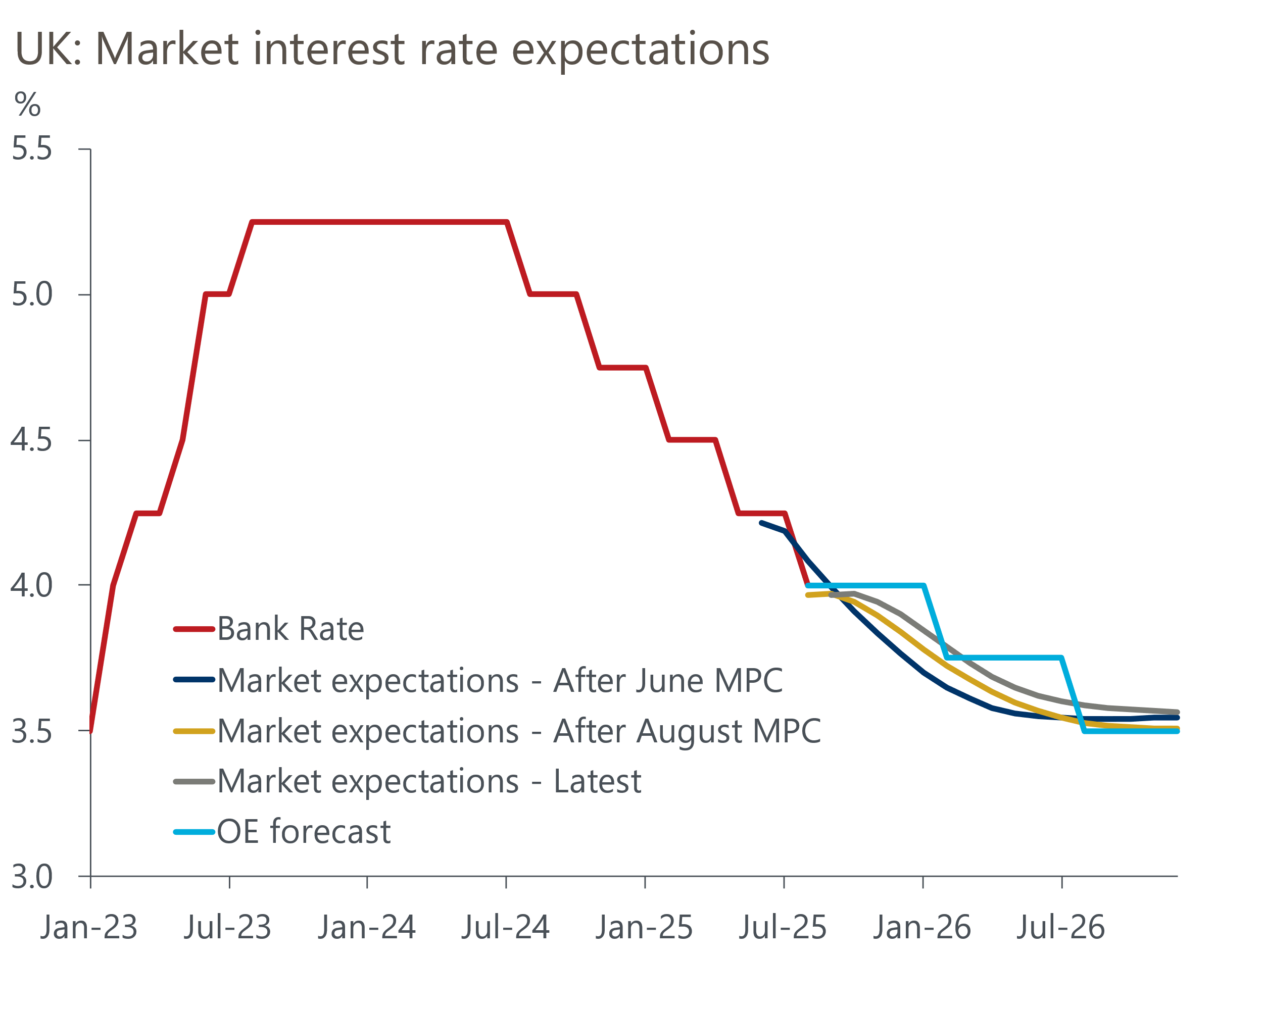
Sources: Oxford Economics, Haver Analytics

